Cheat Sheet 1 – SPL Commands
Title: Splunk Search Processing Language (SPL) Commands
Objective: To understand commonly used SPL commands for searching, filtering, analyzing and investigating security logs.
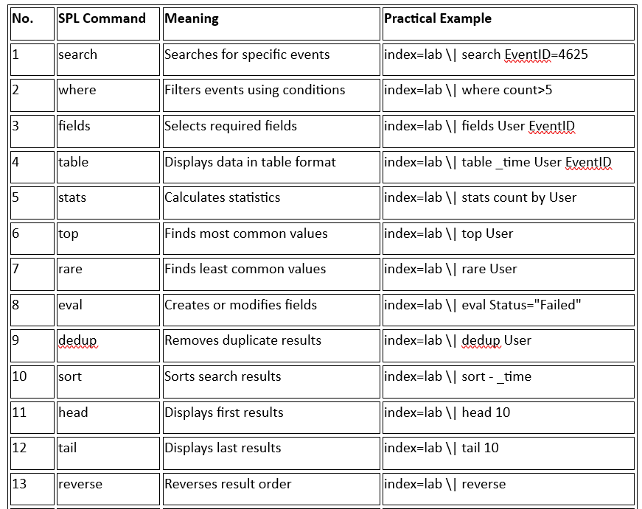
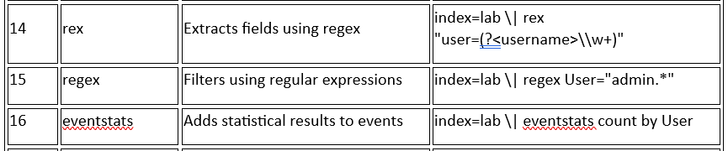
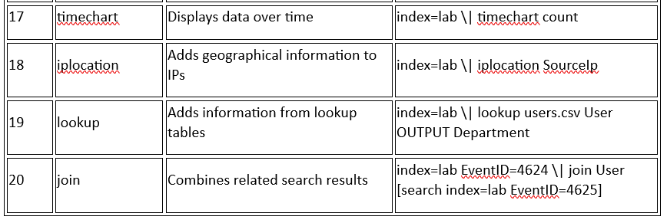

Important SPL Operators
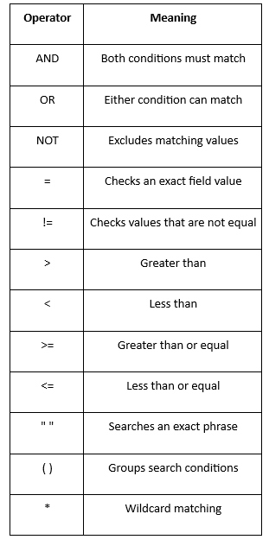

Purpose: Identifies users with the highest number of failed login attempts.
Conclusion: SPL commands help SOC analysts search, filter, organize and analyze security events to identify suspicious activities.

